Web Panel

Summary Description

This web panel are developed by MVC frame work Codeignator. Main project file are in application folder

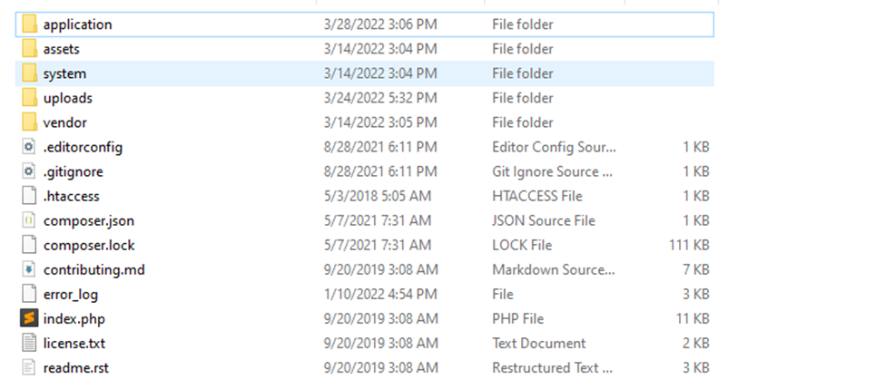

Assets folder containing all the libraries image and plugin used in this project.

Vendor folder are dependencies folder all the dependencies exist in this folder

In application folder,there are different folder

Config.php

All the configatron like database connection and base path are defined in this folder



Base Url is url where script exit

If you change then application/config/config.php

Database connection are exists in database.php

This code is for the database connection

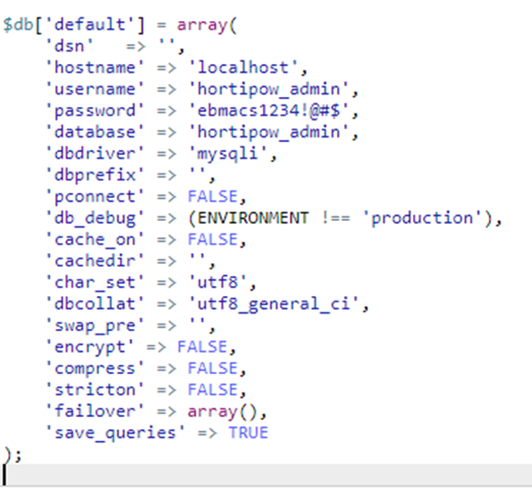

In controller folder File name Site.php in this file we set the basic view of login screen and authenticate the user

This code is for login view that will be show on browser

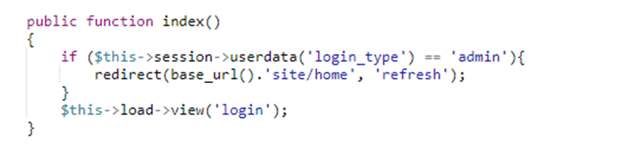

For authenticate the user we call process login function

Using this we authenticate and store session user info

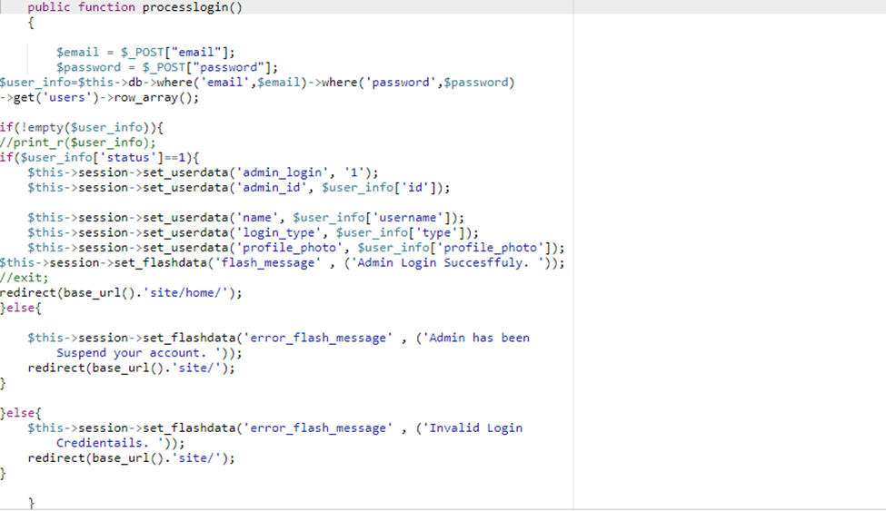

After successful login they will be call home function and load the view according to their type

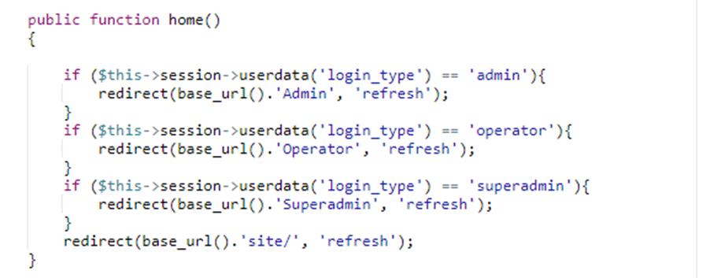

For the Admin now load the Admin script and call index function that will be consist in Admin.php

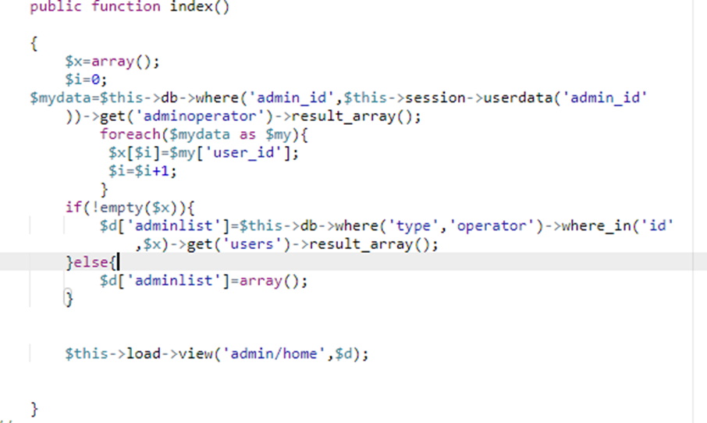

Using this we will get all the operator list that will be contained database

In analytics we will need all the sensor data so we using this function and load their view

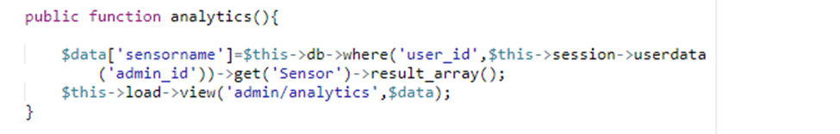

The view code in **application/views/admin/analytics.php**

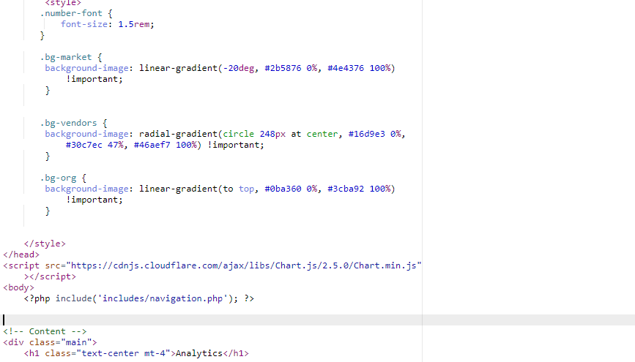

**FOr sensor list this function will be used**

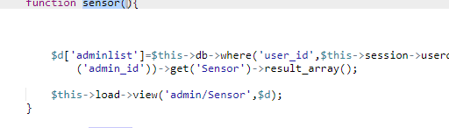

**In this code get the list of sensor and show in sensor .php**

**Output of sensor that will display in your browser**

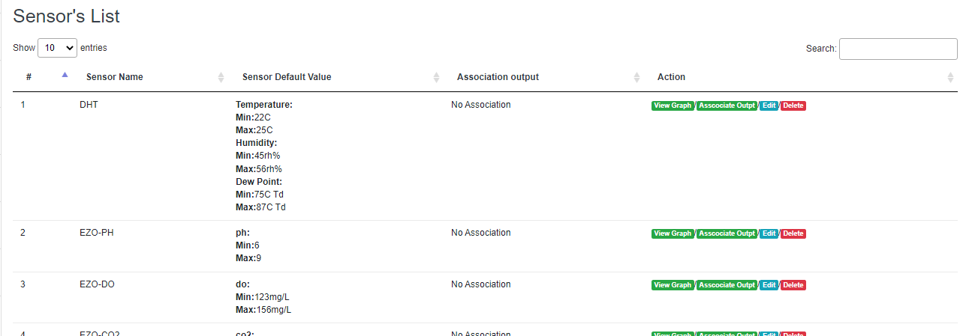

And the code for this view is application **application/views/admin/sensor.php**

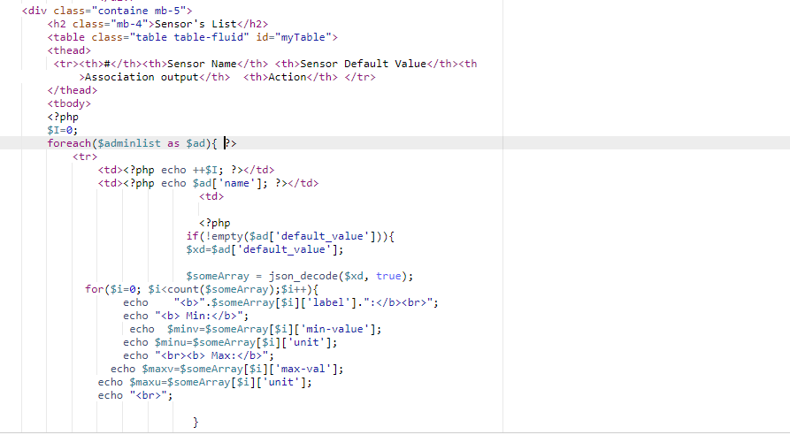

**For add sensor**

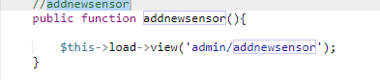

**This function will load addnewsensor that will be exit in view/admin/addnewsensor.php**

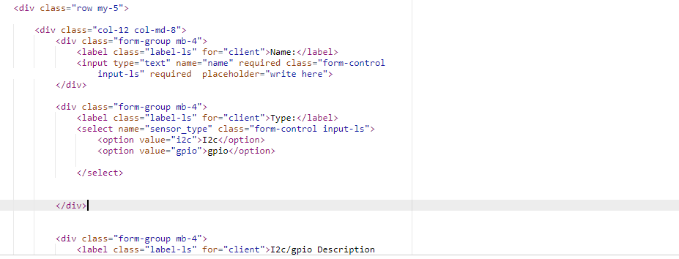

**And add data in data base used this function**

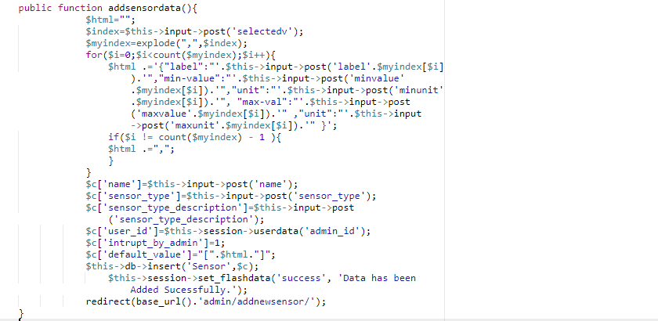

**For sensor Reading we will used this function**

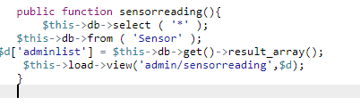

**For Delete Sensor**

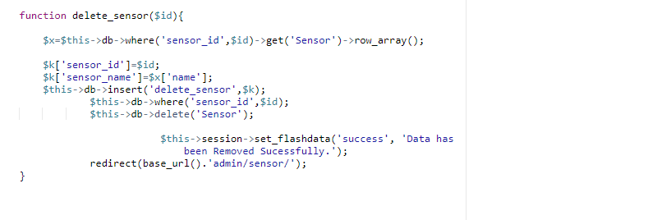

**For update Sensor data**

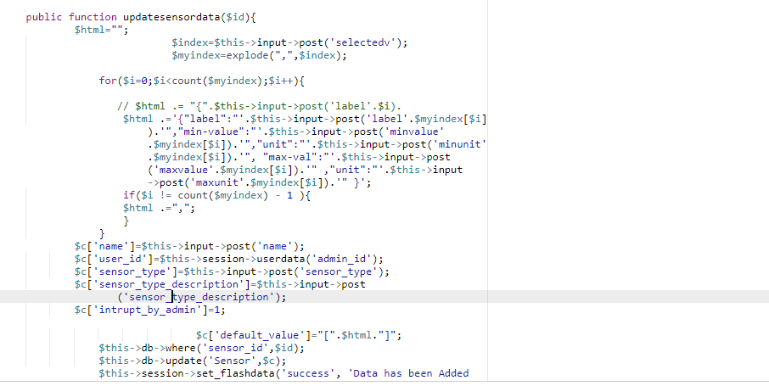

**For COntrol**



**Add control**

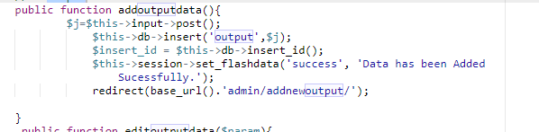

**Update control**

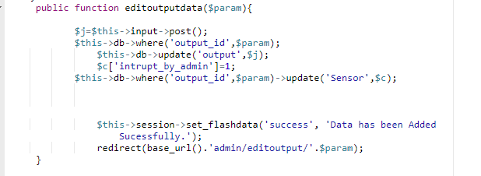

**Delete control**

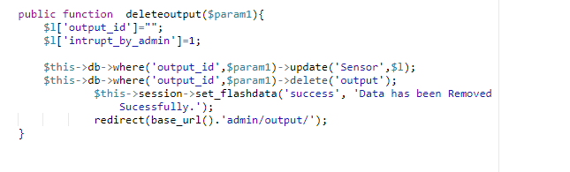

**For cam list**

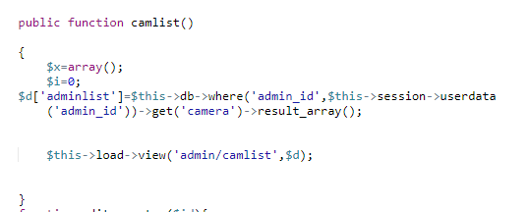

**For view cam**

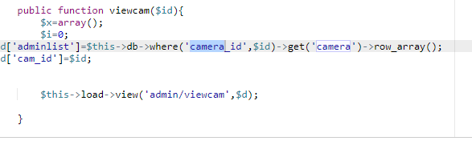

**For delete Cam**

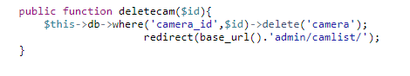

**For cam configuration**

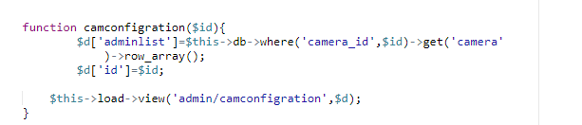

**For cam stop**

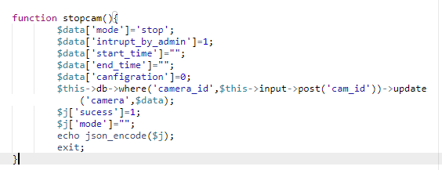

**For Start Cam**

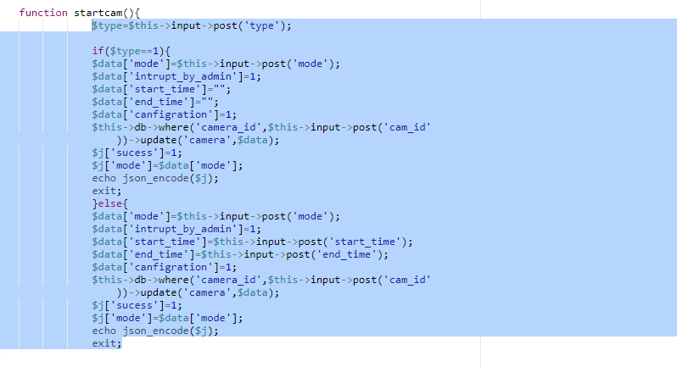

**For profile**

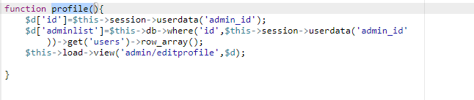

**For edit Profile**

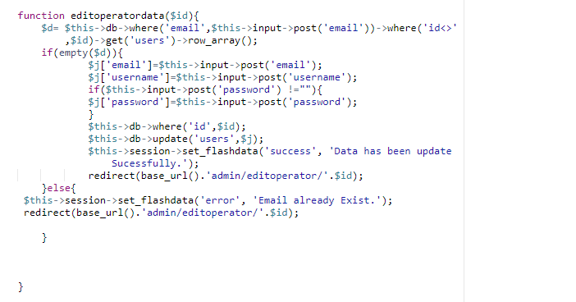

**For add data in sidebar you can use View/admin/includes/navigation.php**

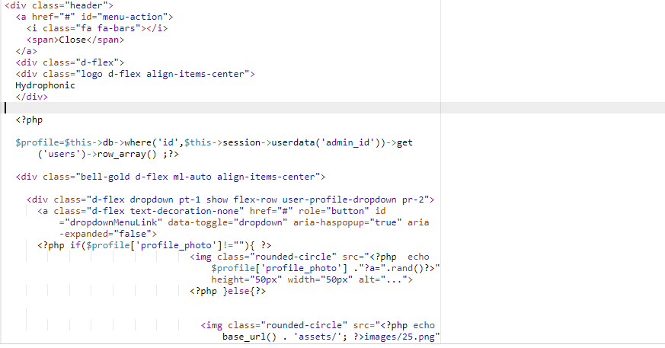

**Adding Css you can add in toplink which is exit in view/admin/include/toplinks.php**

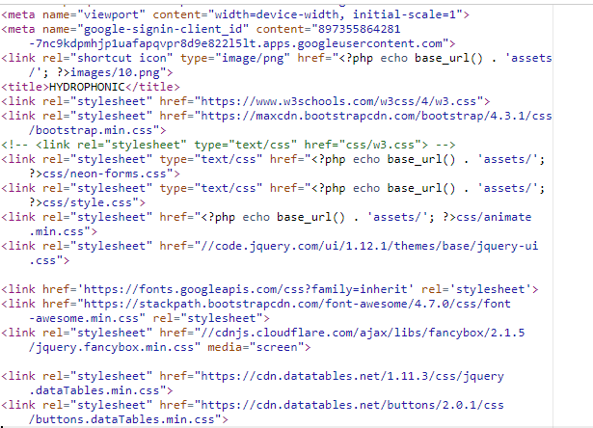

**For adding any js script you will used views/admin/includes/bottom_links.php**

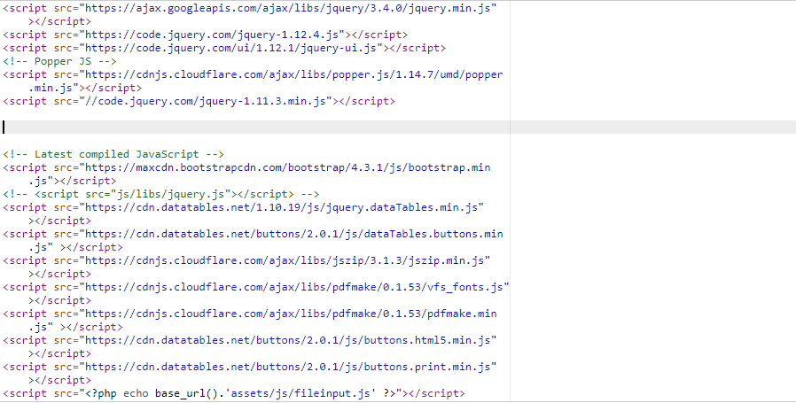

**Operator Controller and operator view will work the same that means admin controller and operator controller will work pretty much the same.**

For the communication between sensor and adminpanel we need an api those for responsible for comunication .so we write an api, Api file are also in controller folder .using api we get and post sensor data in database

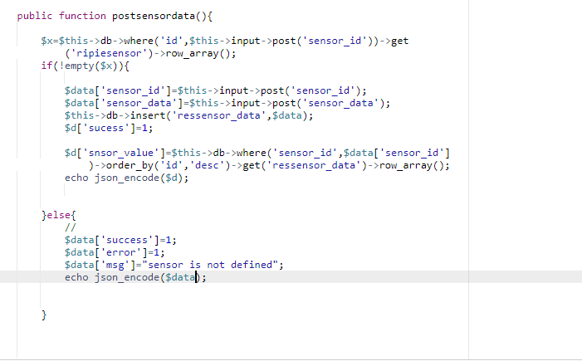

For read sensor data for start

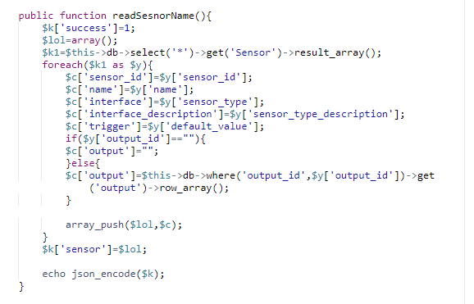

For read interrupt

